PowerTalk Power Club
TM
Offered by PowerTalk Seminars, LLC
Agenda for Tuesday, January 9, 2024

Warm up some hearty lunchtime favorites and join us a few minutes early for casual networking.

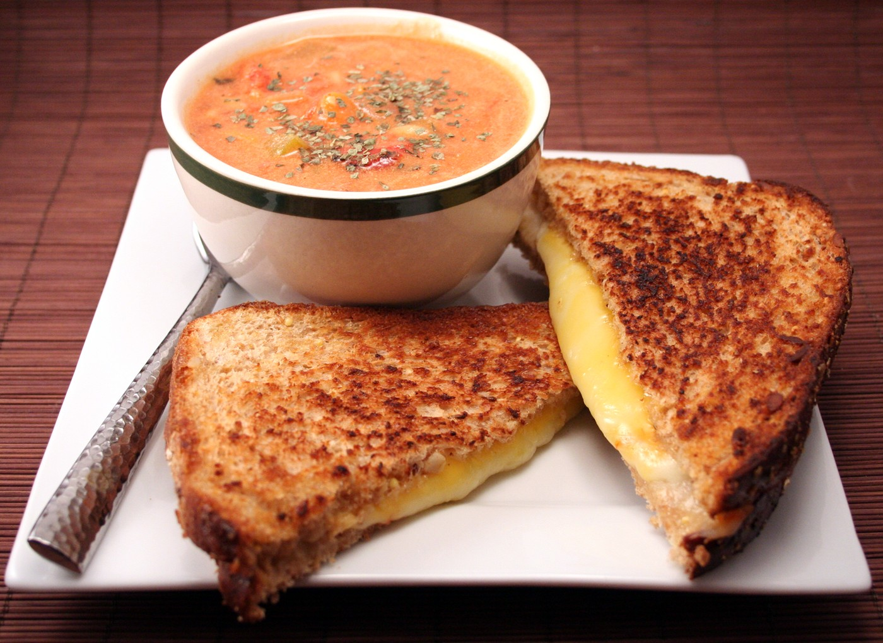

Power Lunch 11:30 AM- 1:00 PM

Share ideas for moving ahead in 2024!

“Developing Leaders, Achieving Dreams,
Helping Build Empowered Teams!”

Our Mission: The mission of the PowerTalk Power Club is to educate, entertain, and engage our Power Pal members to participate in fun, alternative yet complementary professional development meetings where every member has the opportunity to prospect, promote, and present their programs, products, and services in order to enhance their own business and professional growth.
Our Vision: The PowerTalk Power Club is designed to empower you. We invite you to participate as a “Power Pal” Speaker and a Powerful Networker. Our interactive professional learning environment will support your development as a VIP Speaker, Entrepreneur, and Small Business Leader.
Our Values: Members of this club seek to support one another through effective feedback in the form of speaker presentation evaluations, networking and referrals, and sharing resources that can help our members achieve their personal and professional development goals.
Our Overall Objective: Our overall objective is to encourage all our Club Members to continue to grow as business professionals and to help foster a supportive and fun social environment for personal enrichment.

PowerTalk Power ClubTM
Lunch Meeting Agenda
Tuesday, January 9, 2024

OPEN

11:30am President’s Welcome & Brief Introductions Vitalia Bryn-Pundyk, M.Ed/DTM/DPP

11:40am Meeting Emcee’s Opening Karen Hughes
Meeting theme: Reflections
Quote: “"Life can only be understood backwards; but it must be lived forwards."
― Søren Kierkegaard

BODY

11:45am Keynote Speech (10-15 min) Roman Pundyk, DTM/DPP
“Worst Vacation….EVER!”

12:01pm Mini-Workshop Presentation (15-30 min) Roman Pundyk, DTM/DPP
“To Buy or Not to Buy!”

EVALUATIONS

12:32pm Keynote (2-3 min) Vitalia Bryn-Pundyk, M.Ed/DTM/DPP

12:36pm Mini-Workshop (2-3 min) Mike Green

12:40pm Timer’s Report (2-3 min) Stephen Shaner, DTM

General Evaluation Vitalia Bryn-Pundyk, M.Ed/DTM/DPP

Guest Comments Vitalia Bryn-Pundyk, M.Ed/DTM/DPP

CLOSE

12:52pm Member Announcements & Vitalia Bryn-Pundyk, M.Ed/DTM/DPP
President’s Closing Remarks

1:00pm Thank You & Meeting Adjourned! Vitalia Bryn-Pundyk, M.Ed/DTM/DPP
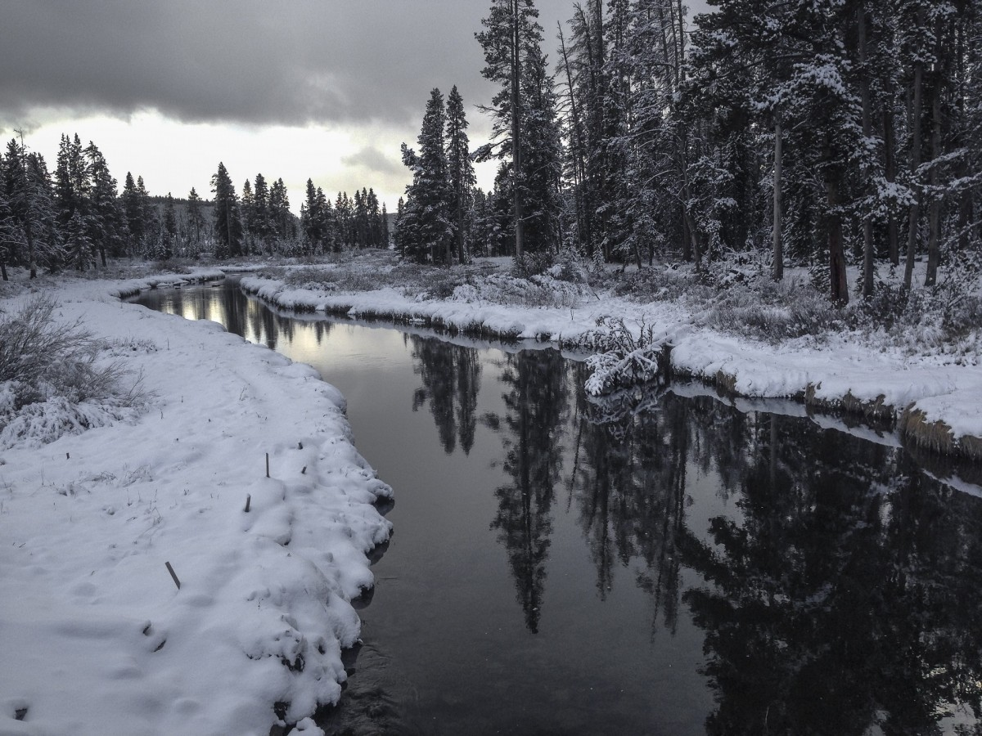

PowerTalk Power Club Roster
Your Power Pals!

Member | Membership | Phone | E-mail | Location
Vitalia Bryn-Pundyk, M.Ed/DTM/DPP | Club President, VIP Full Member | 952-221-1701 | vitalia@powertalkseminars.com | Hutchinson, MN
Bradley Roehrl | Dinner, Pizza | 612-296-5118 | Bradley.roehrl@gmail.com | Minneapolis, MN
Charlie Kundinger | Fridays | 651-283-0017 | Charlieandmolly@msn.com | St. Louis Park, MN
Chris Ciccone, SPP | Dinner | 763-222-6433 | Christineciccone.reliv@yahoo.com | East Bethel, MN
Cindy Karnes | Thursdays | 651-274-2248 | cindylkarnes@gmail.com | St. Paul, MN
Crystal Anderson | Pizza | 612-387-5329 | 4funhiking@gmail.com | Lino Lakes, MN
Diane Windingland, DTM/SPP | Lunch | 612-306-4214 | diane@virtualspeechcoach.com | Spring, TX
Evgeniya Djuranovic | VIP Full Member | 763-496-8604 | Evgeniya.tokareva@gmail.com | Orono, MN
Gwen Briesemeister | Dinner, Pizza | 763-221-6136 | gbriesemeister@charter.net | Delano, MN
Jacqueline Fiore | VIP Full Member | 772-631-8006 | jacquelinefiore27@gmail.com | Minnetonka, MN
Jacquelyn Mooty | Pizza | 952-297-4645 | Jacquelyn.schuette@gmail.com | Edina, MN
Jane Schuette, M.A/DTM/GPP | VIP Full Member | 952-994-6192 | jane@janeschuette.com | Watertown, MN
Jayne Miller | Thursdays | 763-458-1034 | jayne3miller@hotmail.com | Tampa, FL
Julie Nekola | Virtual Asst, VIP Full Member | 612-310-2802 | Julie.Nekola@gmail.com | Plymouth, MN
Kim Windingland, DTM | Lunch | 612-306-4228 | kimwindingland@gmail.com | Spring, TX
Kirsten Kinzler | Dinner, Pizza | 320-583-1877 | Kirsten.kinzler@gmail.com | Hutchinson, MN
Leah Skurdal | Pizza | 651-472-3995 | Leah.skurdal@gmail.com | Moundsview, MN
Lili Korbuly-Johnson, BPP | VIP Full Member | 952-200-9248 | lili@get-lkj.com | St. Louis Park, MN
Lori Ziebarth, BPP | Dinner, Pizza | 612-701-9120 | Lori.ziebarth@gmail.com | Maple Grove, MN
Lynn Wilson | Dinner | 612-751-8876 | nevilleandlynn@gmail.com | North Branch, MN
Michael Carlton, DTM/SPP | Dinner, Pizza, Fridays | 612-750-0098 | Tm.Michael.carlton@gmail.com | Lino Lakes, MN
Michelle Perdue, M.Ed/DTM,SAG | Thursdays | 612-237-0652 | MichelleRPerdue@msn.com | Brooklyn Park, MN
Norm Johnson-Korbuly | VIP Full Member | 612-703-3026 | normjohnson62@gmail.com | St. Louis Park, MN
Roman Pundyk, DTM/DPP | VIP Full Member | 952-221-2319 | pundyk@earthlink.net | Hutchinson, MN
Stephen Shaner, DTM | Thursdays | 931-310-1858 | Stephen@awesomeattitude.net | Red Boiling Springs, TN
Steve Compton, DTM | Thursdays | 651-253-6710 | steve.compton@izoom.net | Zimmerman, MN
Susan Kaulbars | Dinner, Pizza | 612-558-9532 | Susan@FramingSolutionsmn.com | St. Louis Park, MN
Vicki Dolphy, DTM | Pizza | 651-353-8700 | vickidolphy@gmail.com | Stacy, MN
 |  |  |  | Rev. 1/6/2024

PowerTalk Power Club 2024!
Meeting Dates, Times, & Locations

Additional Special Events
January 27 PowerTalk Power Day & Club Anniversary Awards & Recognition Celebration

May 19 PowerTalk Power Club Member Appreciation Annual Paddle Boat Cruise on Lake Minnetonka 11:00am-2:00pm

June 1 PowerTalk Potluck Picnic Party at the Pundyk's 12:00pm-5:00pm

September 18-22 PowerTalk Fall Festival Mini-Conference Retreat

December 14 PowerTalk Holiday Social

For information and registration information on the above events, check out
https://www.powertalkseminars.com/additional-powertalk-programs-and-powerful-events

Early Morning Motivation
Rise ‘n Shine! These early AM Zoom meetings
happen on the 2nd Thursday and the 2nd Friday
of each month from 6:30AM – 9:00AM Central
time.
12 Thursday sessions - $120
12 Friday sessions - $120

Thursdays Fridays
January 11 January 12
February 8 February 9
March 14 March 8
April 11 April 12
May 9 May 10
June 13 June 14
July 11 July 12
August 8 August 9
September 12 September 13
October 10 October 11
November 14 November 8
December 12 December 13

Power Talk Power Lunches |  |  | Power Talk Pizza Panels
Meet on Zoom 11:30AM – 1:00PM on the second Tuesday of each quarter.  4 quarterly sessions - $40 |  |  | Meet at Frankie’s Chicago Style Pizza,  3559 Winnetka Ave. N, New Hope, MN, from 6:00PM-9:00PM on the following Tuesdays.  4 quarterly sessions - $60
January 9
April 9 |  |  | March 12
July 9 |  |  | June 11
October 8 |  |  | September 10
 |  |  | December 10
 | 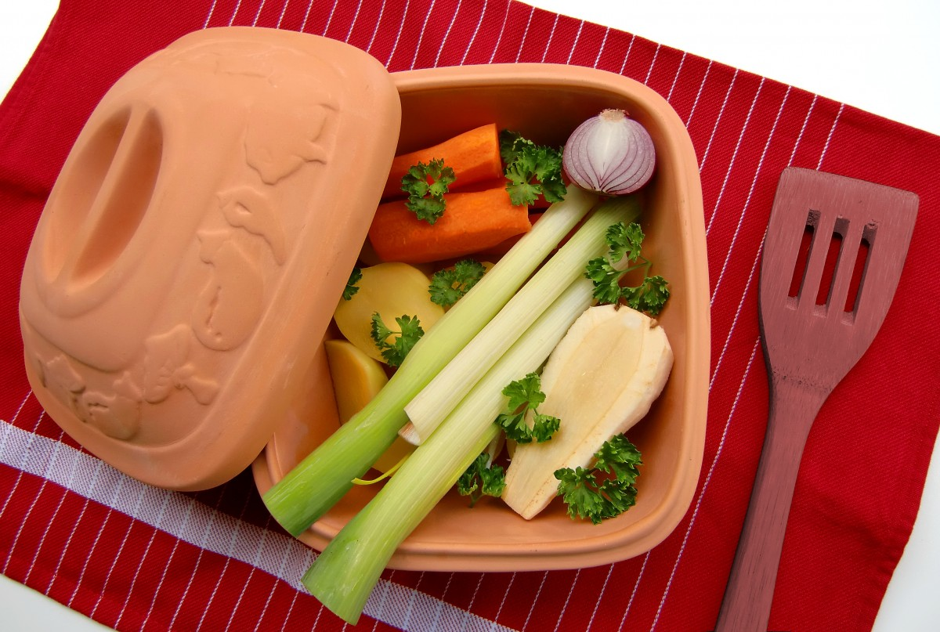
Power Talk Prime Time Dinners
Meet in the Power Talk Party and Workshop Room at Pundyk’s Private Lakeshore Residence in Hutchinson from 5:00PM-9:00PM on the following Tuesdays.
4 Quarterly sessions - $80
February 13
May 14
August 6
November 13

